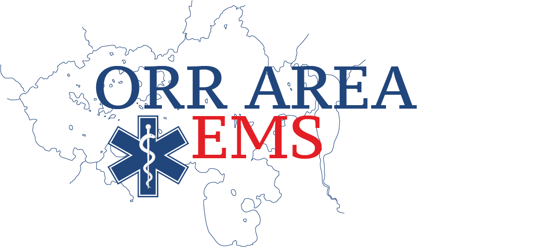
ORR AMBULANCE SERVICE IS SEEKING VOLUNTEERS

COME VOLUNTEER IN NORTHERN MINNESOTA!

Please consider joining our volunteer team. We offer on-call pay and run stipends. Orr Ambulance serves Kabetogama, Buyck, Crane Lake, Boundary Waters, Greany, and we have mutual aid agreements with Cook Ambulance, Littlefork Ambulance, and Bois Forte Ambulance.

If not licensed as Emergency Medical Services Responder (1st Responder) or Technician (EMT) not a problem, we will assist you with getting certified. We look forwarding to you joining our team.

We hope to hear from you soon!

Best regards,
Donna Hoffer
Ambulance Director
orrambulance1@centurytel.net
218-780-3798

